Right Up There With Buckingham Palace
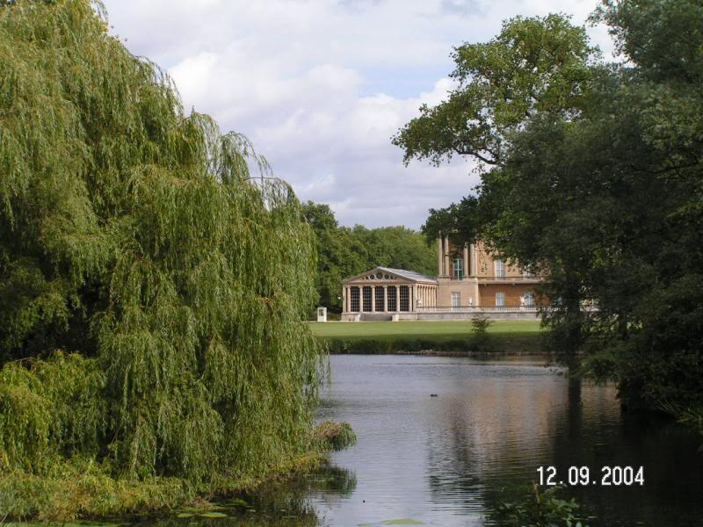
When President Obama breezed through St. Louis during a recent fund-raising event, he also enjoyed a dinner at a private St. Louis residence. Of special interest to Mackey Mitchell was a comment made by visiting reporters who were “wowed,” by the home’s palatial pool house designed by our very own Tom Moore. The press corp was sequestered in the super-cabana with its large screen TV, a second story loft, and a thoroughly-equipped kitchen. One reporter remarked that it was the nicest pool house they had ever stayed in while covering the president. “No. 2 actually,” the reporter corrected herself- Buckingham Palace was pretty nice!

