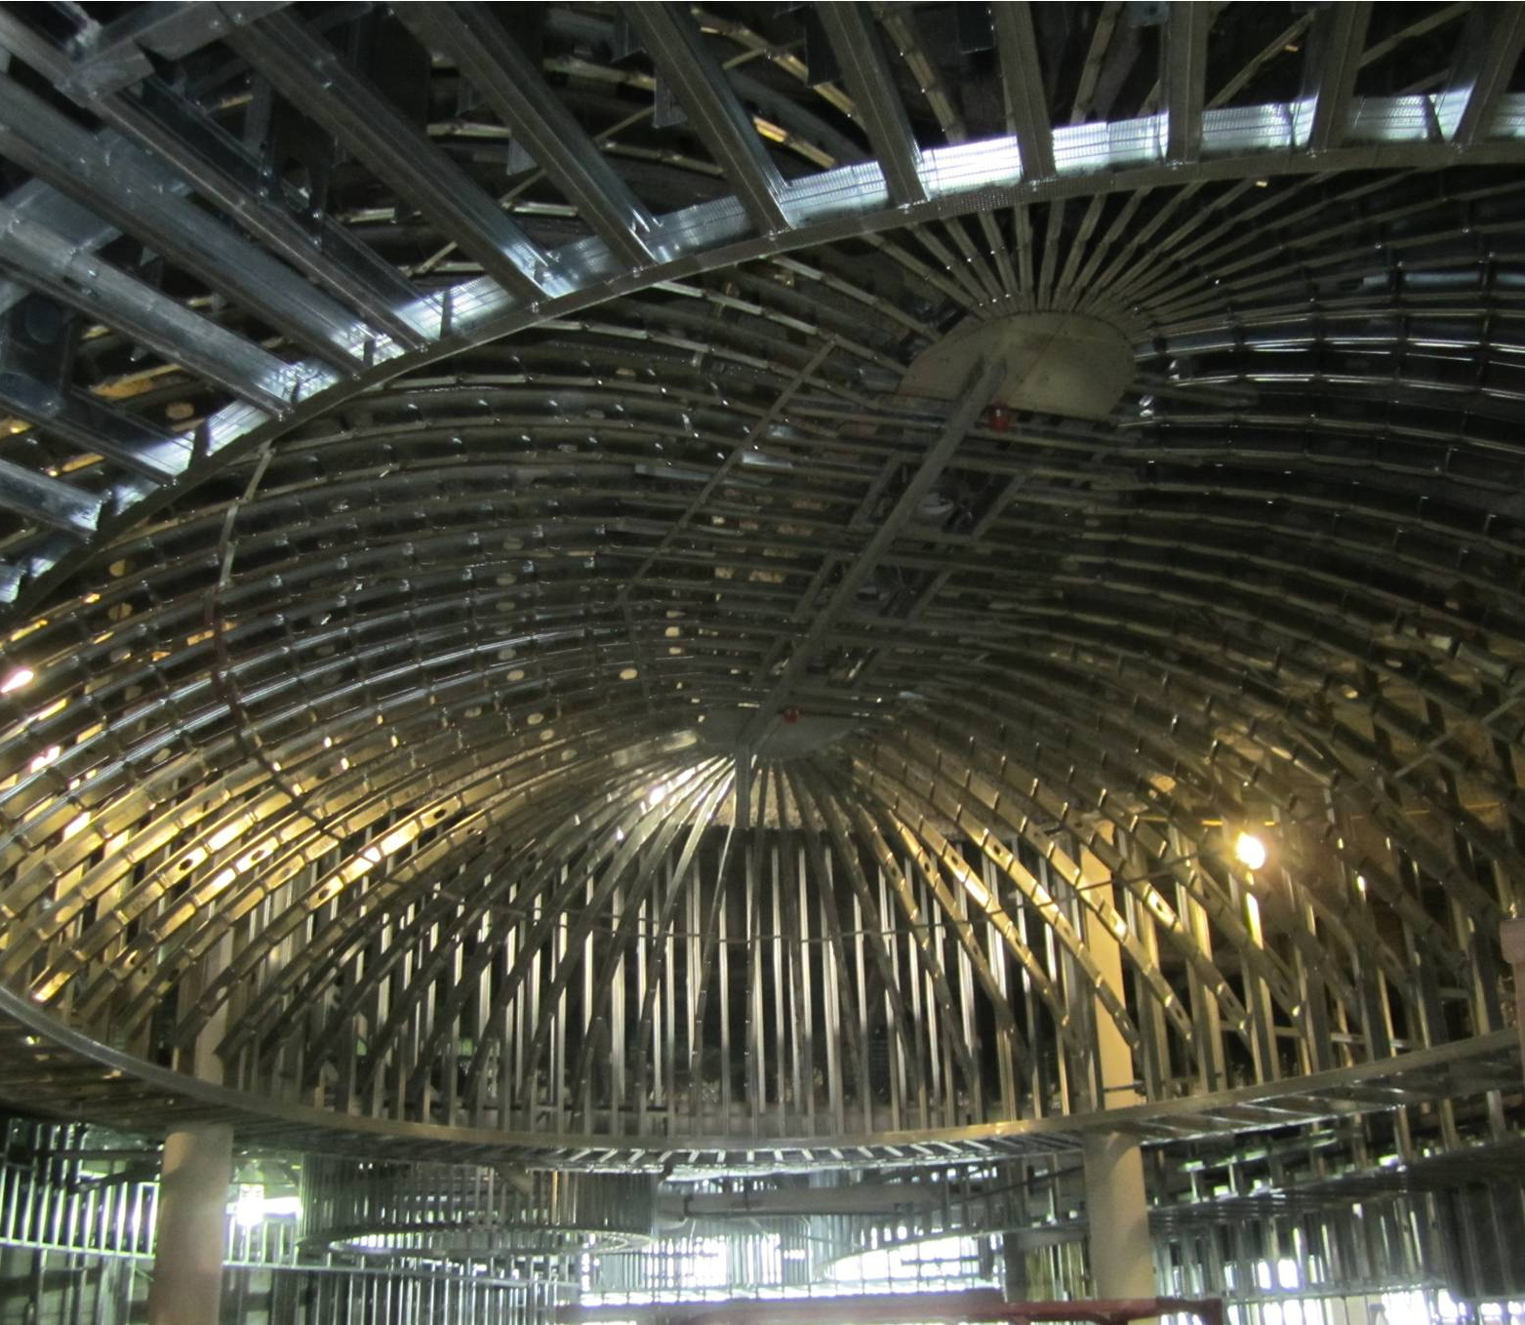
Beauty Beneath
The University of Wisconsin’s Lakeshore Housing project is now 50% complete. The 5-story , 229,000GSF building has food service and dining, a 264 seat multipurpose and 426 beds. Quality wise, project manager Andy Noll says it’s one of the highest quality projects he’s ever worked on. Solid and well-built, the building should wear well for a long time. Andy’s was impressed with one of the interior ceilings anad it labryinth of stainless steel bars and steel exhaust dictwork in the kitchen/servery area. It’s almost a shame to cover the awesome stud work in the domed ceiling with drywall. Lakeshore’s Mackey Mitchell project team includes: Dan Mitchell, Paul Wuennenberg, Sara Goester, Gwynn Zivic, Greg Frankenfeld, rachel Raterman, Javier Esteban, and Andy Noll.

